Test Case: tc002_SPX_Dev5_Crear_Requisicion_Spot_Con_FAD_Tipo_Cobro_CC
Step 1 - Enter username and password and click to button Enter : Credentials Entered
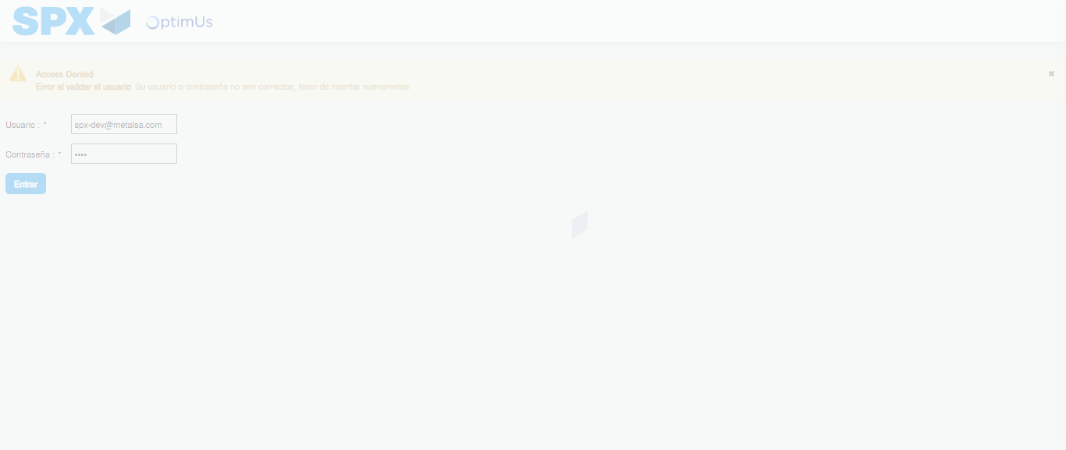Image file-name: QC_Testing-tc002_SPX_Dev5_Crear_Requisicion_Spot_Con_FAD_Tipo_Cobro_CC-1789484031687

Step 2 - Select to UEN and Access to Spot Buy Requisitions : UEN Correctly selected and Correct access
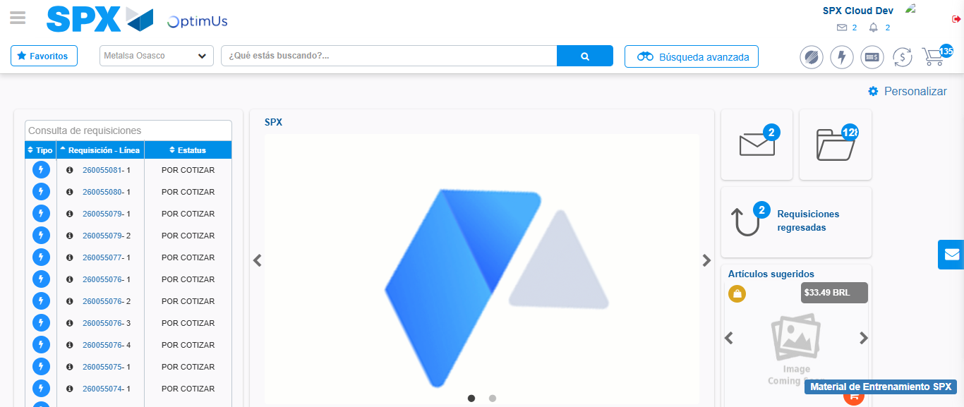Image file-name: QC_Testing-tc002_SPX_Dev5_Crear_Requisicion_Spot_Con_FAD_Tipo_Cobro_CC-1789484054736

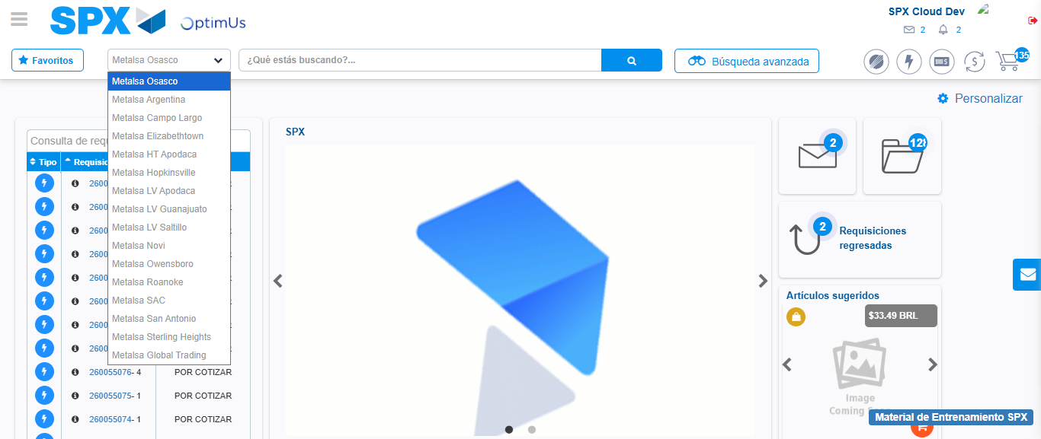Image file-name: QC_Testing-tc002_SPX_Dev5_Crear_Requisicion_Spot_Con_FAD_Tipo_Cobro_CC-1789484055246

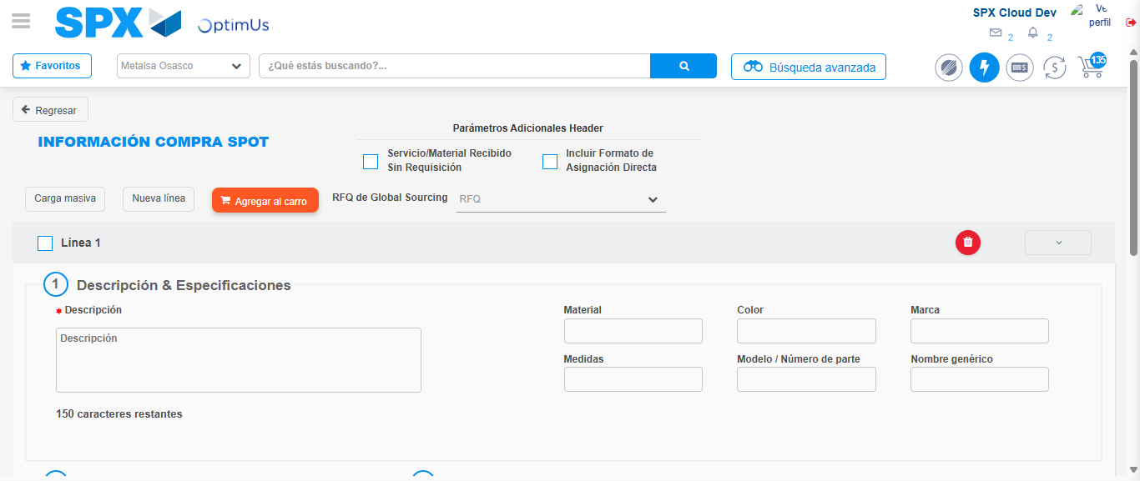Image file-name: QC_Testing-tc002_SPX_Dev5_Crear_Requisicion_Spot_Con_FAD_Tipo_Cobro_CC-1789484059204

Step 3 - Add FAD to Requisition: FAD Successfully Added
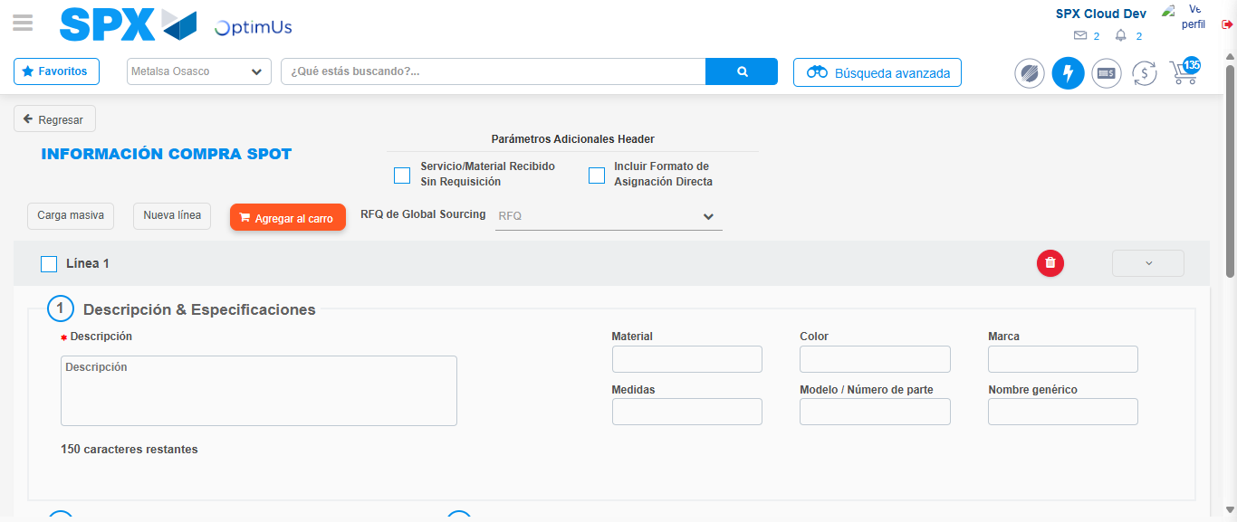Image file-name: QC_Testing-tc002_SPX_Dev5_Crear_Requisicion_Spot_Con_FAD_Tipo_Cobro_CC-1789484059486

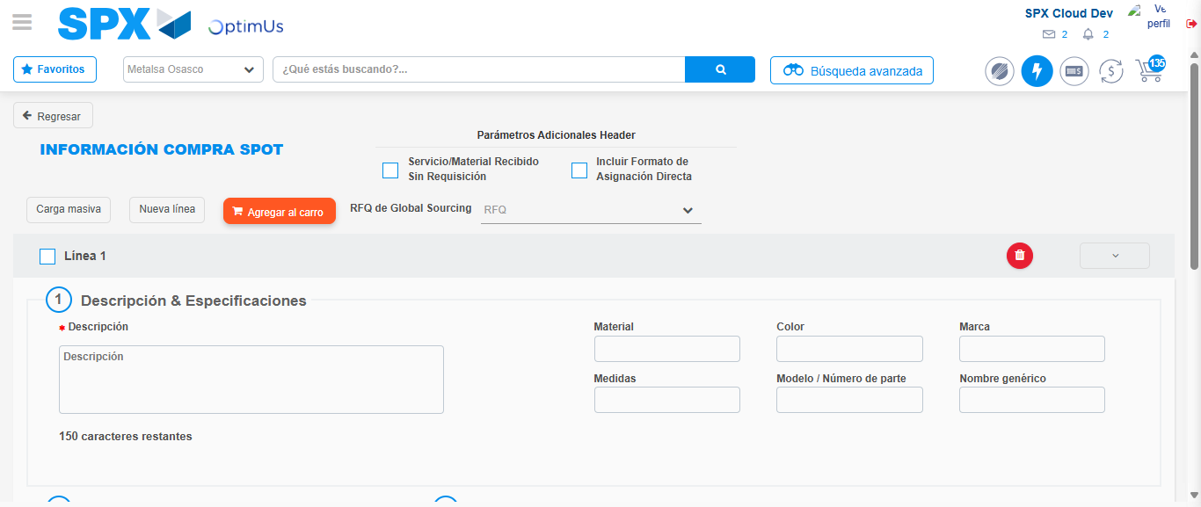Image file-name: QC_Testing-tc002_SPX_Dev5_Crear_Requisicion_Spot_Con_FAD_Tipo_Cobro_CC-1789484059730

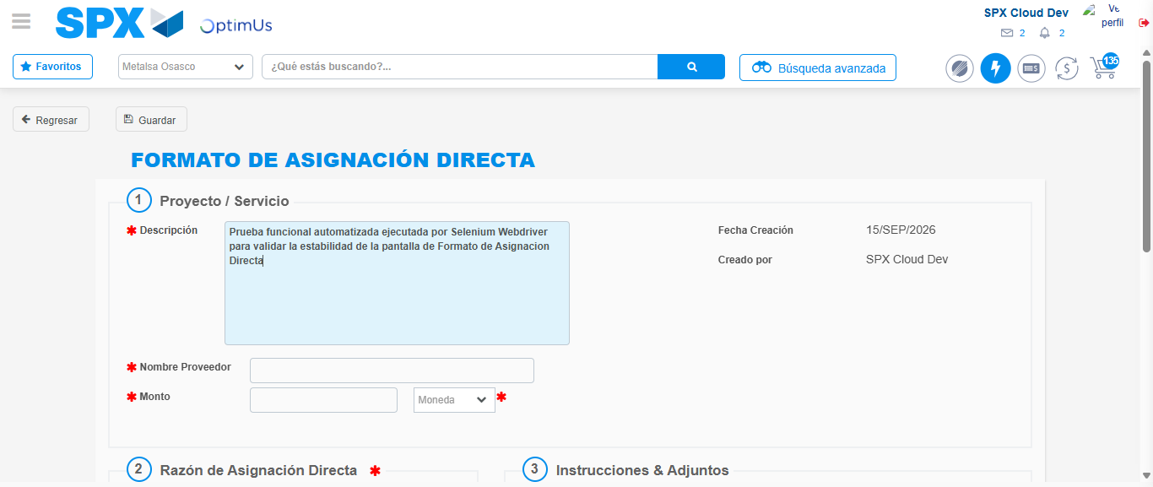Image file-name: QC_Testing-tc002_SPX_Dev5_Crear_Requisicion_Spot_Con_FAD_Tipo_Cobro_CC-1789484062466

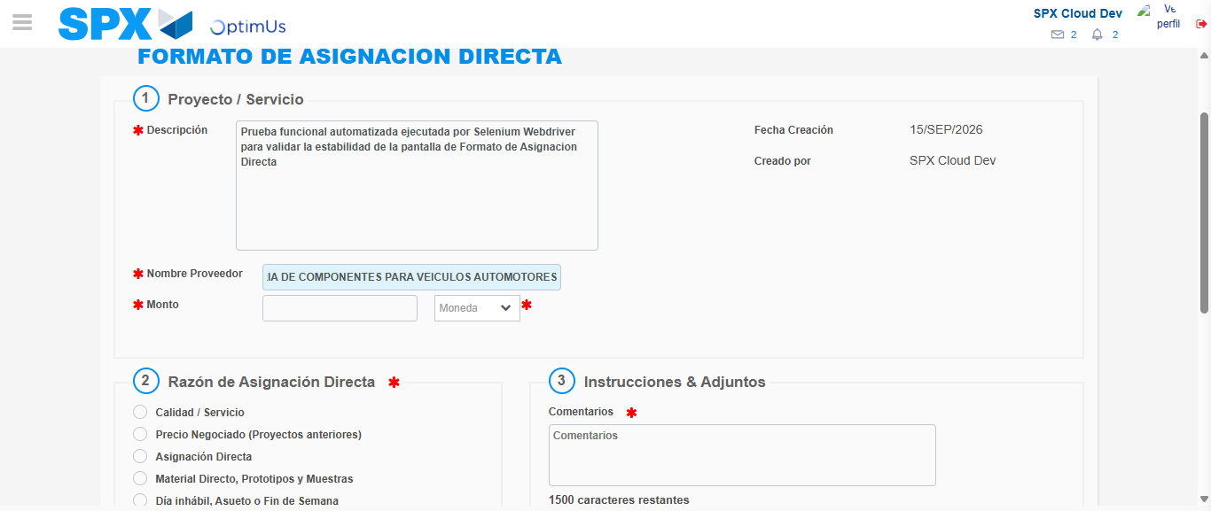Image file-name: QC_Testing-tc002_SPX_Dev5_Crear_Requisicion_Spot_Con_FAD_Tipo_Cobro_CC-1789484071290

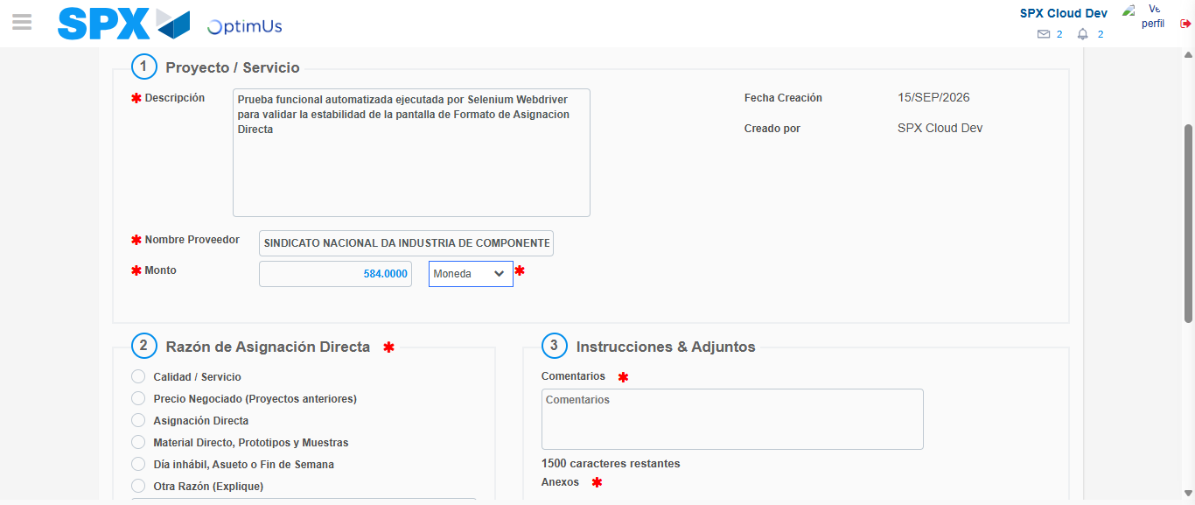Image file-name: QC_Testing-tc002_SPX_Dev5_Crear_Requisicion_Spot_Con_FAD_Tipo_Cobro_CC-1789484071676

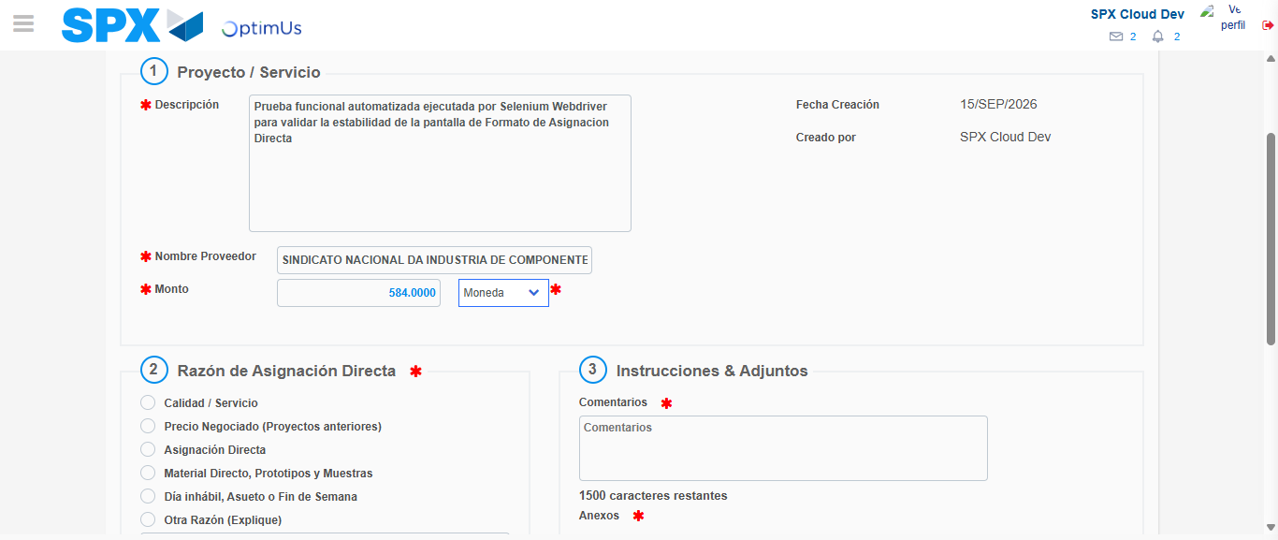Image file-name: QC_Testing-tc002_SPX_Dev5_Crear_Requisicion_Spot_Con_FAD_Tipo_Cobro_CC-1789484071859

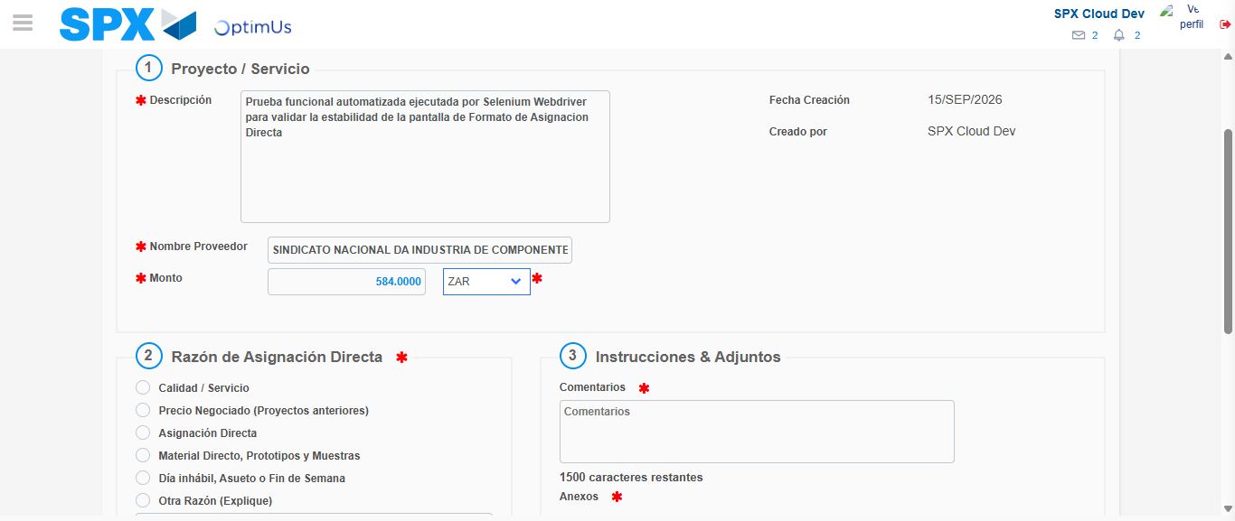Image file-name: QC_Testing-tc002_SPX_Dev5_Crear_Requisicion_Spot_Con_FAD_Tipo_Cobro_CC-1789484072182

Image file-name: QC_Testing-tc002_SPX_Dev5_Crear_Requisicion_Spot_Con_FAD_Tipo_Cobro_CC-1789484072390

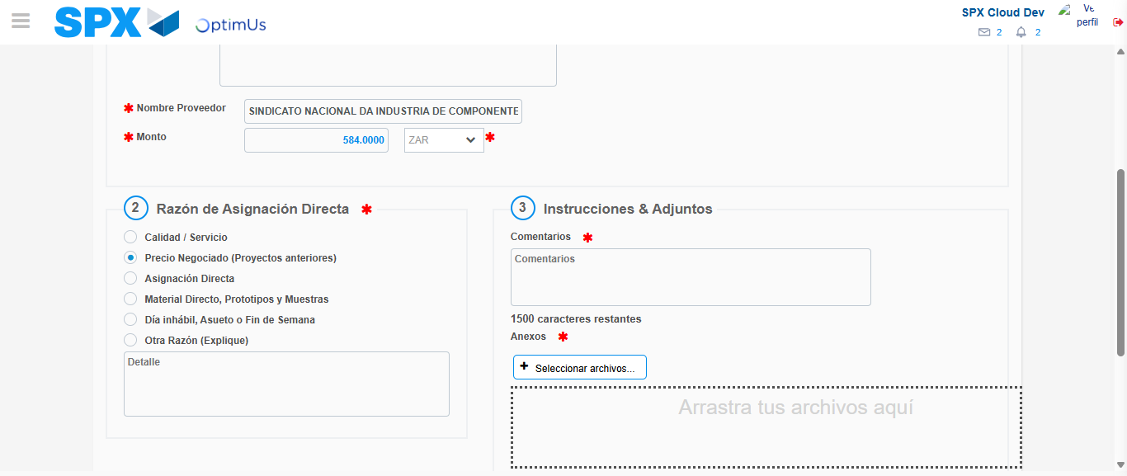Image file-name: QC_Testing-tc002_SPX_Dev5_Crear_Requisicion_Spot_Con_FAD_Tipo_Cobro_CC-1789484073153

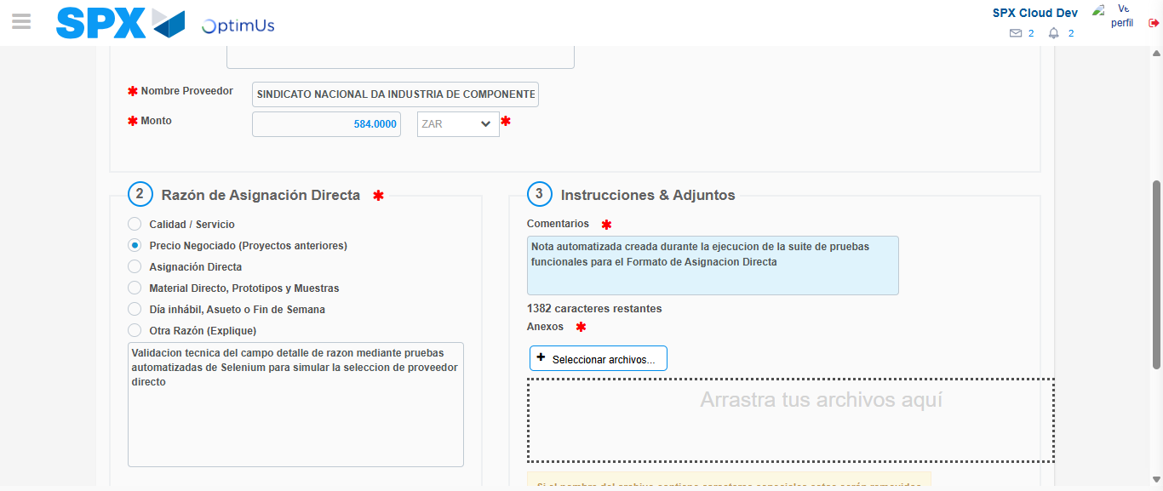Image file-name: QC_Testing-tc002_SPX_Dev5_Crear_Requisicion_Spot_Con_FAD_Tipo_Cobro_CC-1789484084029

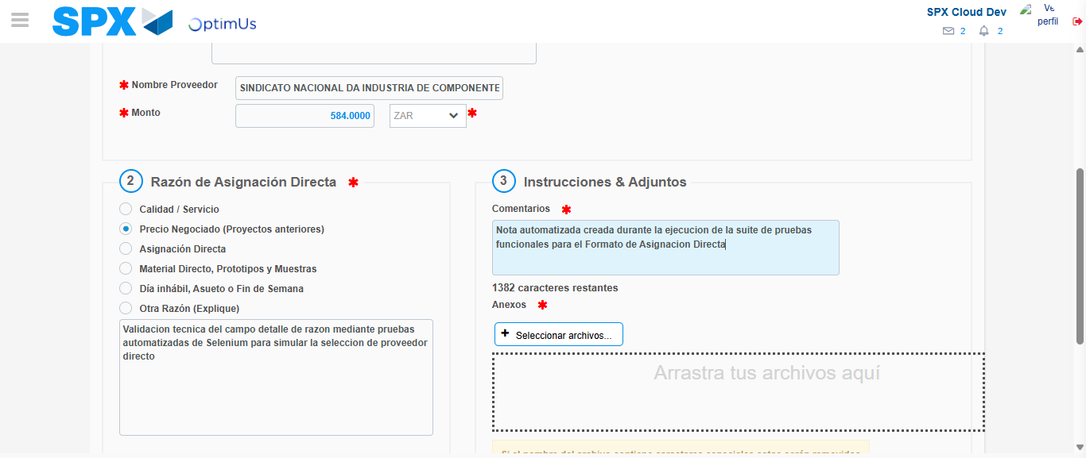Image file-name: QC_Testing-tc002_SPX_Dev5_Crear_Requisicion_Spot_Con_FAD_Tipo_Cobro_CC-1789484084653

Step 4 - Data Capture Spot Buy Requisition: Data captured correctly
Image file-name: QC_Testing-tc002_SPX_Dev5_Crear_Requisicion_Spot_Con_FAD_Tipo_Cobro_CC-1789484059486

Image file-name: QC_Testing-tc002_SPX_Dev5_Crear_Requisicion_Spot_Con_FAD_Tipo_Cobro_CC-1789484059730

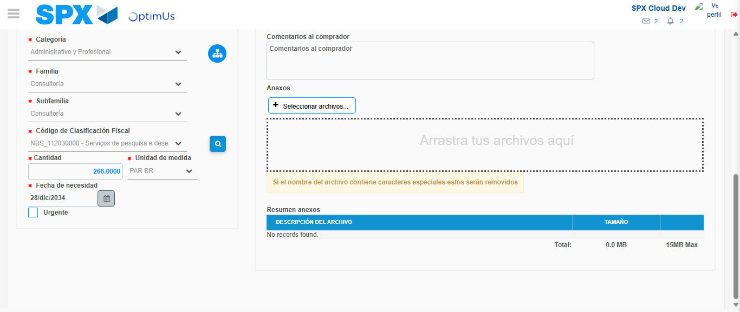Image file-name: QC_Testing-tc002_SPX_Dev5_Crear_Requisicion_Spot_Con_FAD_Tipo_Cobro_CC-1789484101553

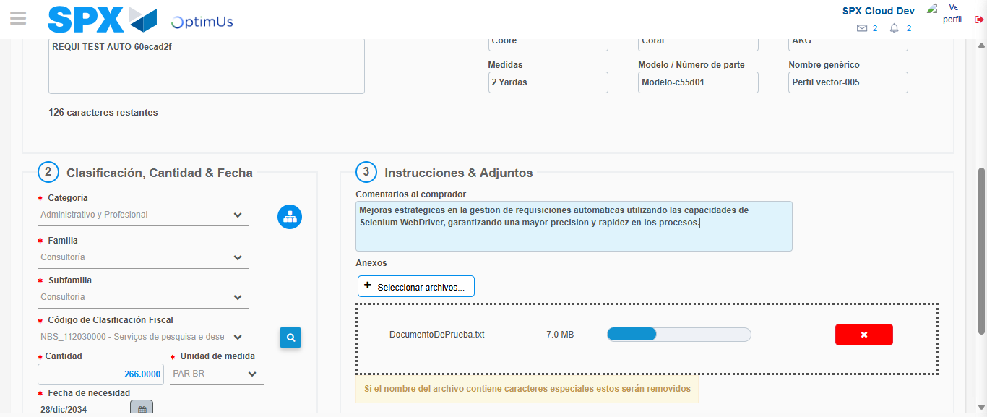Image file-name: QC_Testing-tc002_SPX_Dev5_Crear_Requisicion_Spot_Con_FAD_Tipo_Cobro_CC-1789484102231

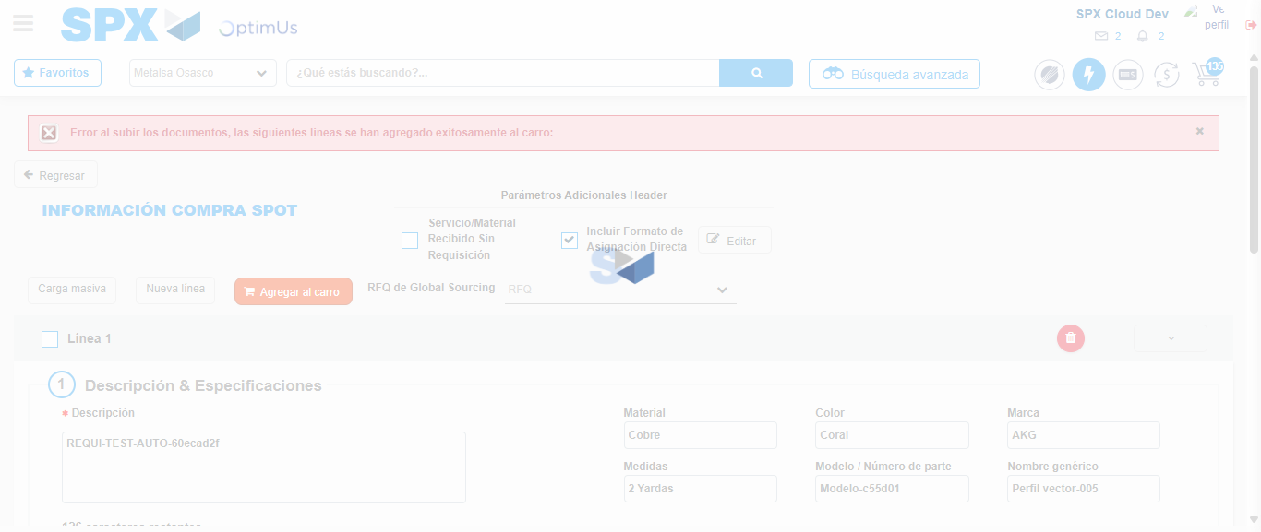Image file-name: QC_Testing-tc002_SPX_Dev5_Crear_Requisicion_Spot_Con_FAD_Tipo_Cobro_CC-1789484115067

Step 8 - Return to Main Page SPX : Return to Main Page SPX
Image file-name: QC_Testing-tc002_SPX_Dev5_Crear_Requisicion_Spot_Con_FAD_Tipo_Cobro_CC-1789484054736

Image file-name: QC_Testing-tc002_SPX_Dev5_Crear_Requisicion_Spot_Con_FAD_Tipo_Cobro_CC-1789484055246

Image file-name: QC_Testing-tc002_SPX_Dev5_Crear_Requisicion_Spot_Con_FAD_Tipo_Cobro_CC-1789484059204

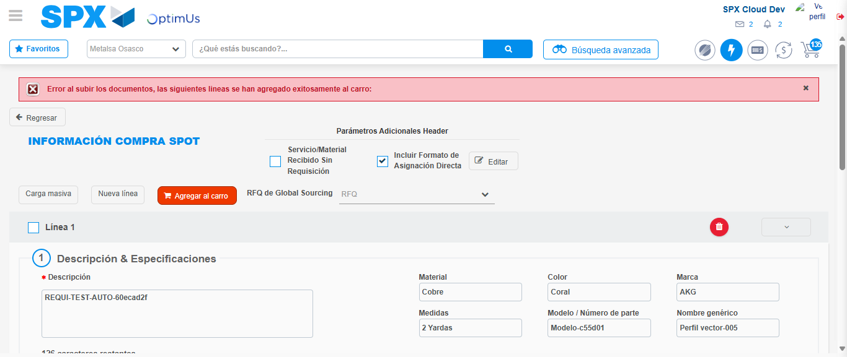Image file-name: QC_Testing-tc002_SPX_Dev5_Crear_Requisicion_Spot_Con_FAD_Tipo_Cobro_CC-1789484117643

Image file-name: QC_Testing-tc002_SPX_Dev5_Crear_Requisicion_Spot_Con_FAD_Tipo_Cobro_CC-1789484117829

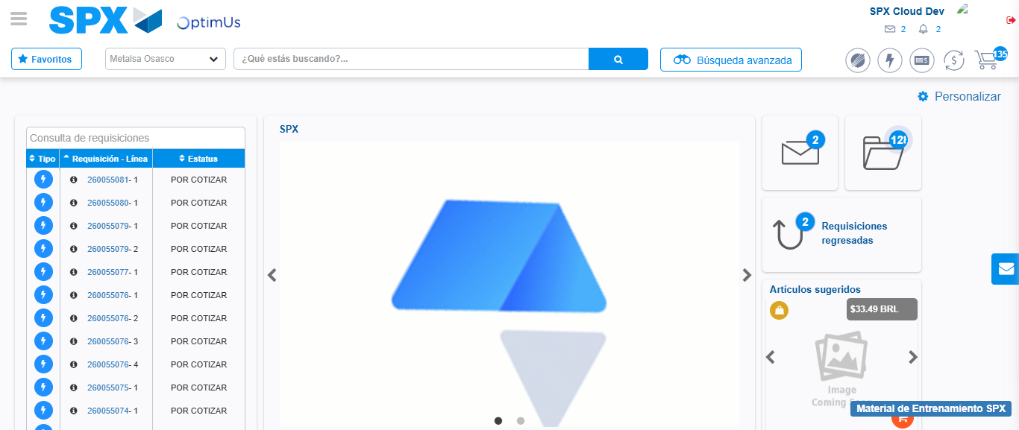Image file-name: QC_Testing-tc002_SPX_Dev5_Crear_Requisicion_Spot_Con_FAD_Tipo_Cobro_CC-1789484139075

Step 9 - Log Out : Log Out SPX
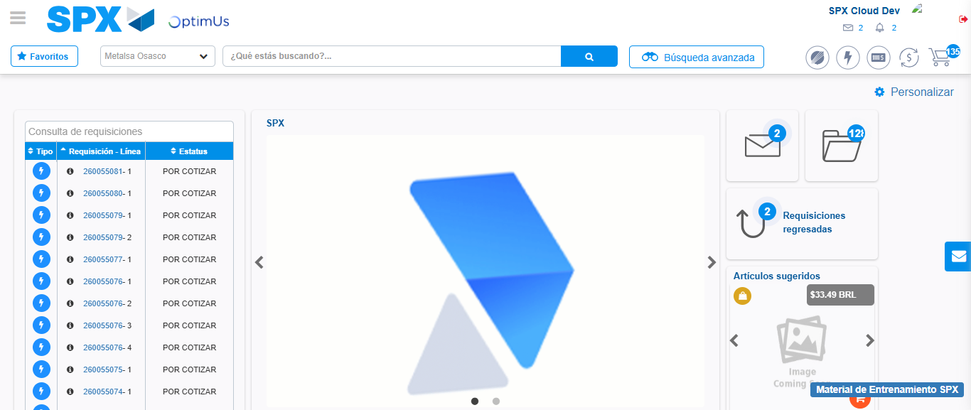Image file-name: QC_Testing-tc002_SPX_Dev5_Crear_Requisicion_Spot_Con_FAD_Tipo_Cobro_CC-1789484139375

